

# Agriculture, Food, and Natural Resources Program Approval

Thank you for your interest in submitting an Agriculture, Food, and Natural Resources (AFNR) program approval file for the 2024-2025school year. Whether this is a brand-new program, or you are up for the 5-year renewal, this is the application form you need to fill out. Below you’ll find instructions for completing the approval form.

If you have questions, please contact Shelli Sowles (shelli.sowles@state.mn.us)

Why would you consider submitting a program approval file?

Program approval is the initial eligibility requirement for a school district to access federal Perkins funding through their local Perkins consortium, and state CTE Revenue.

To determine which programs the districts has previously had approved, visit the [Program Approval Database](https://education.mn.gov/mdeprod/idcplg?IdcService=GET_FILE&dDocName=004741&RevisionSelectionMethod=latestReleased&Rendition=primary).

To view a list of available program codes, course codes, and the corresponding teacher licensure requires, visit [Table C](https://education.mn.gov/mdeprod/idcplg?IdcService=GET_FILE&dDocName=049191&RevisionSelectionMethod=latestReleased&Rendition=primary).

Instructions:

**Step 1:**

Gather your program materials. In order to complete the program approval form, you will need the following items:

* The AFNR courses offered at the school district. At a minimum, the district must offer two courses in order to be a program. Course names, program code, and course codes will be reported on Tab 4 of the application form spreadsheet.
* Names, emails, teacher license ([PELSB](https://mn.gov/pelsb/)) File Folder Numbers, and building locations of all of the teachers in the program.
* List of advisory committee members specific to the AFNR program and their contact information.
* Leadership activities and career exploration activities that students within your program participate in, including FFA if applicable.
* The syllabus for each course that will be included in your program approval file. Course content reflected on the syllabus should demonstrate alignment to the AFNR Frameworks with content that includes: career exploration, authentic assessments, safety training, certifications, and alignment to workforce.

**Once these materials are pulled together, completing the form should require about 10-20 minutes.**

**Step 2:**

Navigate to MDE’s program approval webpage located at <https://education.mn.gov/MDE/dse/cte/progApp/>

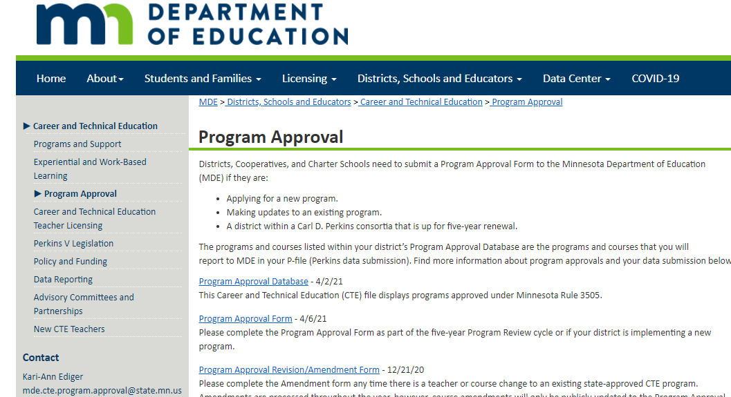

Click on the link called “Program Approval Form.”

This will download a Microsoft Excel file. Open the file.

**Step 3:** Navigate to the very first tab of the spreadsheet labeled “Directions and Checklists. Review this tab carefully. 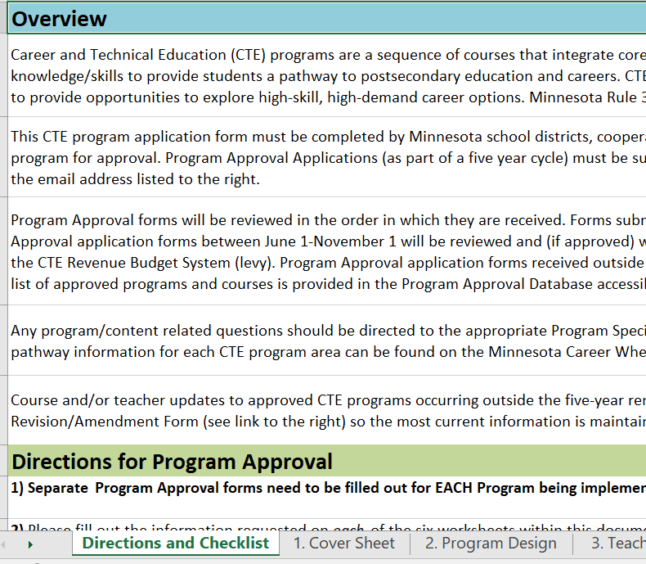

This tab also includes step-by-step instructions for completing this form as well as contact information if you need additional assistance.

**Step 4:** The next step is to begin to fill out the form. Navigate to the tab labeled “1. Cover Sheet.” Provide answers to rows 3-13.

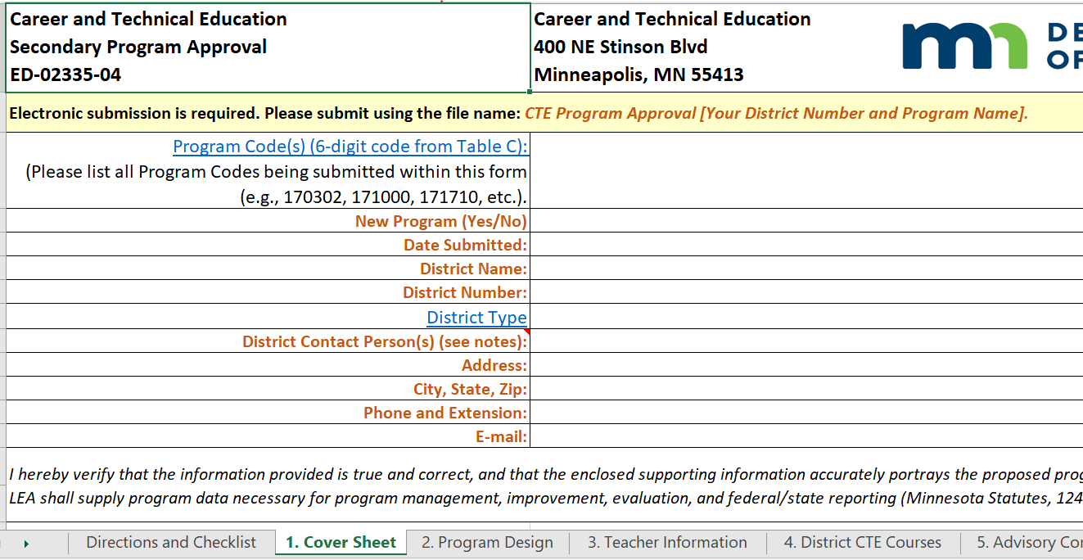

**Program codes include:**

019901

019090

Reference Table C for additional details.

**District Contact Person(s):**

This should be the person who can answer questions about the application. For example, who can answer questions about a syllabus or advisory committee? Consider listing a lead teacher AND an administrator.

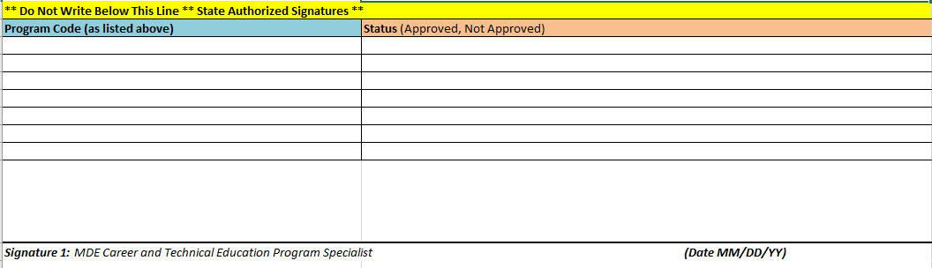

The remainder of the Cover Sheet (rows 26-40) is for MDE use. Once a program is approved, MDE signatures will be added to this section. There is no need for you to do anything with these rows.

**Step 5:** The next step is to fill out the tab labeled “2. Program Design.” This tab asks you to provide evidence about the curricular components of your program.

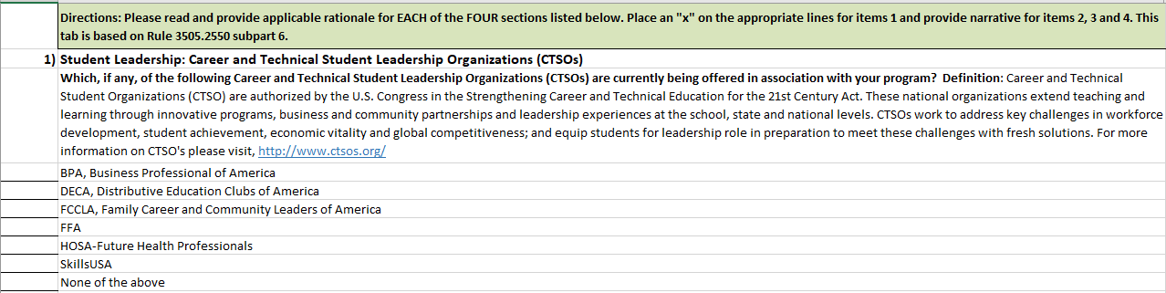

Questions 1 and 2 are about student leadership.

**In question 1**, explain briefly what leadership activities your students are involved in. If it’s on the syllabus, note “See syllabus.”

**In question 2** only mark the student organization if FFA is purposefully embedded into your program.

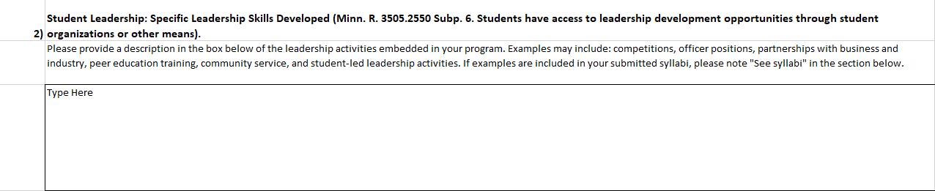

**In Question 3,** explain briefly how students connect their future career interests. Do students research careers, hear from industry professional, or visit work sites? If this is on the syllabus, note “See syllabus.”

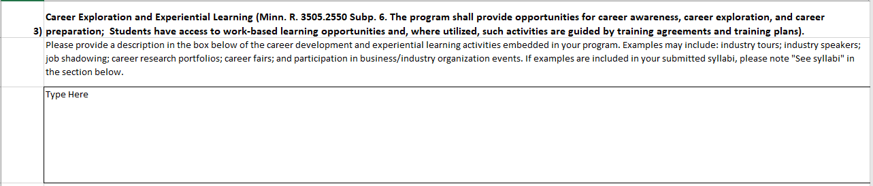

**In Question 4,** explain briefly how students receive safety instruction. If this is on the syllabus, note “See syllabus.”

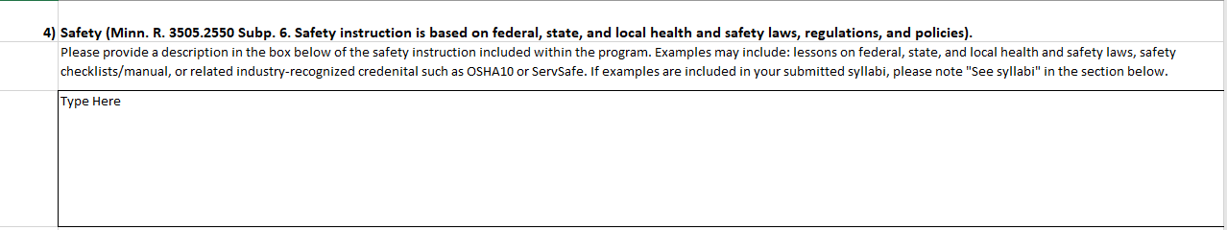

**Step 6:**

List one teacher per row.

Double check to make sure the PELSB-assigned File Folder Number is correct. Errors in the File Folder Number can delay the approval process.

If you need an out of field permission (OFP) for the program, please work with your district to start this process as soon as possible. The program cannot be approved until the OFP process is complete.

The next step is to fill out the tab labeled “3. Teacher Information.” This tab asks you to provide information about the teachers providing instruction within your program. You will focus on columns A-F. MDE will complete columns G-J after you submit your file.

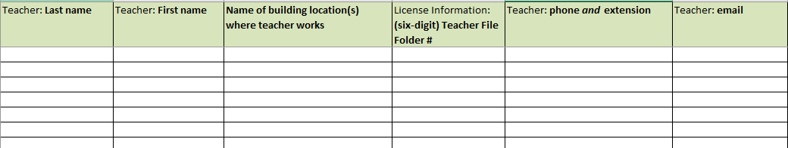

**Step 7:** The next step is to fill out the tab labeled “4. District CTE Courses.” This tab asks you to provide information about the teachers providing instruction within your program. **You will complete columns A-L**. Rows 2-5 provide an example of how to accurately complete the form. Begin entering your information in row 7.

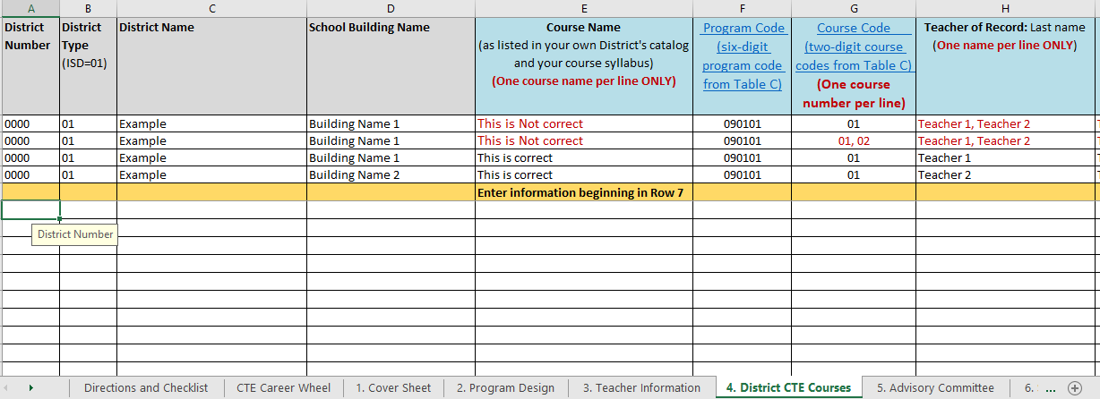

**List only one teacher and one course code per row.**

You must include at least two courses.

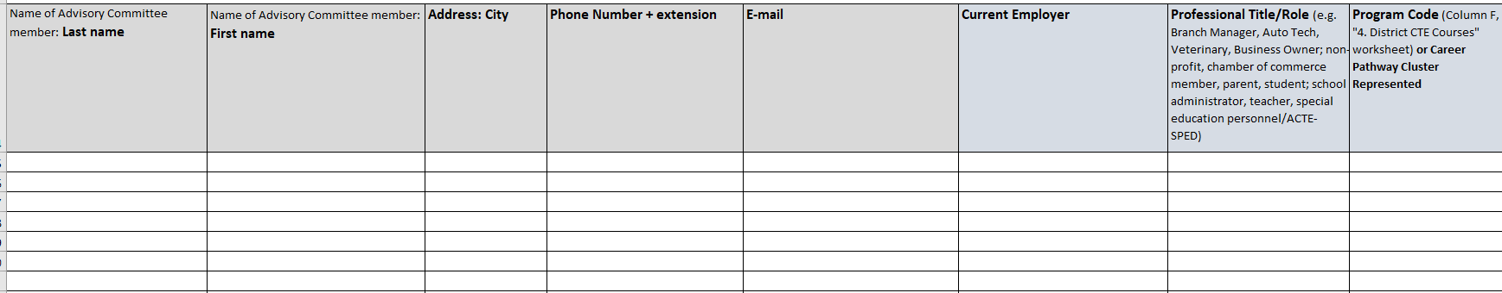**Step 8:** The next step is to fill out the tab labeled “5. Advisory Committee.” This tab asks you to provide information about the individuals, particularly from business and industry, who provide you with recommendations on how to administer your work-based learning program. You will enter information in **columns A-H**, beginning in row 15.

**Step 9:** READY TO SUBMIT: When all tabs are completed submit your documents (**spreadsheet application form, syllabus for each course**, additional evidance as needed) along with a training agreement, training plan, and evaluation plan if you are applying for a 019090 program) to [mde.cte.program.approval@state.mn.us](mailto:mde.cte.program.approval@state.mn.us).

Next Steps:

After you have submitted your program approval materials, MDE program specialists will review your program approval form and reach out to you with any questions. If you have any questions in the meantime, please contact Shelli Sowles (shelli.sowles@state.mn.us).